**Web Technology for bioinformatics**

Name - Dharineesh K S Date - 13/11/2021

Regno - 123013012 Ex.no - 07

**Aim:**

To know the nature of interactions in crystallized molecules using PHP scripts.

**Algorithm:**

1. Read the file using PHP file open syntax.
2. The coordinates are in the Scientific notation. Convert it to engineering notation

Example :

1. 1.54E+01 can be converted to 15.4.
2. 1.54E-01 can be converted to 0.154

Presence of a bond critical point (BCP) between interacting atoms.

Use PHP syntax:

&lt;?php

$number =1.54E-01 ;

$txt = sprintf(&quot;%f&quot;,$number);

echo $txt;

?&gt;

C. Find the Euclidean distance between the atoms (Br and B1) , (B1 and Br) and save the distances as variable newdist .The value of the distance is in Bohr radius.

D. Change the Bohr radius value into Angstroms using the formula given below and save it as ang_dis 1bohr radius =0.5292A°

E. Use the following vanderwaal_constants associative array and apply the following criteria.

$vanderwaal_constants

=array(&quot;H&quot;=&gt;1.2,&quot;C&quot;=&gt;1.70,&quot;O&quot;=&gt;1.52,&quot;N&quot;=&gt;1.55,&quot;He&quot;=&gt;1.4,&quot;F&quot;=&gt;1.47,

&quot;Si&quot;=&gt;2.10,&quot;P&quot;=&gt;1.80,&quot;S&quot;=&gt;1.80,&quot;Cl&quot;=&gt;1.75,&quot;As&quot;=&gt;1.85,&quot;Se&quot;=&gt;1.90,&quot;Br&quot;=&gt;1.85,&quot;Te&quot;=&gt;2.06,&quot;I&quot;=&gt;1.9

8);

a. Extract the value from the vanderWaal constant associative array for the atom Br. Then

subtract the calculated distance between the first two atoms (Br,B) from the Vander Waal

Constant value and assigned it as variable rd

b. Extract the value from the van der Waal constant associative array for the atom Br. Then

subtract the calculated distance between the second two atoms (B,Br) from the Vander

Waal Constant value and assigned it as variable ra

c. Interpretation :

If rd &gt;ra , print a message saying “Distance Criteria Satisfied”

If (rd+ra ) &gt;0 and (rd-ra) &gt;0 ,print the message “Hydrogen Bond” otherwise it is “Van der Waals”

**Program:**

**The code below is written in an html file:**

**<!DOCTYPE html>**

**<head>**

**<title>Upload file</title>**

**</head>**

**<body>**

**<!--**

**name : Dharineesh K S**

**regno : 123013012**

**-->**

**<form method="post" action="hbond.php" enctype="multipart/form-data">**

**<center>**

**<label>Upload file</label>**

**<input type="file" name="upload">**

**<br>**

**<br>**

**<input type="submit" value="upload file">**

**</center>**

**</form>**

**</body>**

**</html>**

**Program:**

**The code below is written in a php file:**

**<?php**

**/\***

**Author : Dharineesh K S**

**Regno : 123013012**

**\*/**

**echo "**

**<html>**

**<head>**

**<title>Identify interactions</title>**

**<style type=\"text/css\">**

**body {**

**font-family: \"Times New Roman\";**

**}**

**table {**

**width: 50%;**

**}**

**tr:nth-child(even) {**

**background-color: #f2f2f2 ;**

**}**

**</style>**

**</head> ";**

**echo"<body>";**

**$filename = $_FILES['upload']['name'];**

**$filesize = $_FILES['upload']['size'];**

**$file_temp_loc = $_FILES['upload']['tmp_name'];**

**move_uploaded_file($file_temp_loc,"upload/$filename");**

**$fh = fopen("upload/$filename","r");**

**$coordinates = array();**

**$tt = array();**

**$k = 0;**

**while (!feof($fh))**

**{**

**$line = fgets($fh);**

**preg_match_all("/-?\d.\d+E[+-]\d+/",$line,$coordinates);**

**$tt[$k][0] = sprintf("%f",$coordinates[0][0]);**

**$tt[$k][1] = sprintf("%f",$coordinates[0][1]);**

**$tt[$k][2] = sprintf("%f",$coordinates[0][2]);**

**$k++;**

**}**

**// print_r($tt);**

**// print_r($tt[1][0]);**

**// print_r($tt[0][0]);**

**// print_r($tt[2][0]);**

**$vanderwaal_const = array('H'=>1.2,'C'=>1.70,"O"=>1.52,"N"=>1.55,'He'=>1.4,'F'=>1.47,"Si"=>2.10,'P'=>1.80,'S'=>1.80,'Cl'=>1.75,"As"=>1.85,'Se'=>1.90,'Br'=>1.85,'Te'=>2.06,'I'=>1.98);**

**//first**

**$xsq = ($tt[1][0]-$tt[0][0])*($tt[1][0]-$tt[0][0]);**

**$ysq = ($tt[1][1]-$tt[0][1])*($tt[1][1]-$tt[0][1]);**

**$zsq = ($tt[1][2]-$tt[0][2])*($tt[1][2]-$tt[0][2]);**

**$dist1 = sqrt($xsq+$ysq+$zsq)*0.5292;**

**$rd = $vanderwaal_const['H']-$dist1;**

**// second**

**$xsq = ($tt[2][0]-$tt[1][0])*($tt[2][0]-$tt[1][0]);**

**$ysq = ($tt[2][1]-$tt[1][1])*($tt[2][1]-$tt[1][1]);**

**$zsq = ($tt[2][2]-$tt[1][2])*($tt[2][2]-$tt[1][2]);**

**$dist2 = sqrt($xsq+$ysq+$zsq)*0.5292;**

**$ra = $vanderwaal_const['O']-$dist2;**

**//third**

**$xsq = ($tt[4][0]-$tt[3][0])*($tt[4][0]-$tt[3][0]);**

**$ysq = ($tt[4][1]-$tt[3][1])*($tt[4][1]-$tt[3][1]);**

**$zsq = ($tt[4][2]-$tt[3][2])*($tt[4][2]-$tt[3][2]);**

**$dist3 = sqrt($xsq+$ysq+$zsq)*0.5292;**

**$rd1 = $vanderwaal_const['H']-$dist3;**

**// four**

**$xsq = ($tt[5][0]-$tt[4][0])*($tt[5][0]-$tt[4][0]);**

**$ysq = ($tt[5][1]-$tt[4][1])*($tt[5][1]-$tt[4][1]);**

**$zsq = ($tt[5][2]-$tt[4][2])*($tt[5][2]-$tt[4][2]);**

**$dist4 = sqrt($xsq+$ysq+$zsq)*0.5292;**

**$ra1 = $vanderwaal_const['O']-$dist4;**

**echo "**

**<table border=1 align= 'center'>**

**<tr>**

**<th>Atom1</th>**

**<th>Atom2</th>**

**<th>rd</th>**

**<th>rd</th>**

**<th>rd-ra</th>**

**<th>rd+ra</th>**

**<th width=10px> Hydrogen Bond / Van der waal interaction </th>**

**</tr>";**

**if (($rd+$ra)>0 && ($rd-$ra))**

**{**

**echo "**

**<tr>**

**<th>H</th>**

**<th>O</th>**

**<th>$rd</th>**

**<th>$ra</th>**

**<th>",$rd-$ra,"</th>**

**<th>",$rd+$ra,"</th>**

**<th>Hydrogen bond</th>**

**</tr>**

**";**

**}**

**else**

**{**

**echo "**

**<tr>**

**<th>H</th>**

**<th>O</th>**

**<th>$rd</th>**

**<th>$ra</th>**

**<th>",$rd-$ra,"</th>**

**<th>",$rd+$ra,"</th>**

**<th>Van der waal</th>**

**</tr>**

**";**

**}**

**if (($rd1+$ra1)>0 && ($rd1-$ra1))**

**{**

**echo "**

**<tr>**

**<th>H</th>**

**<th>O</th>**

**<th>$rd1</th>**

**<th>$ra1</th>**

**<th>",$rd1-$ra1,"</th>**

**<th>",$rd1+$ra1,"</th>**

**<th>Hydrogen bond</th>**

**</tr>**

**";**

**}**

**else**

**{**

**echo "**

**<tr>**

**<th>H</th>**

**<th>O</th>**

**<th>$rd1</th>**

**<th>$ra1</th>**

**<th>",$rd1-$ra1,"</th>**

**<th>",$rd1+$ra1,"</th>**

**<th>Vanderwaal</th>**

**</tr>**

**";**

**}**

**echo "**

**</table>**

**";**

**echo"</body>";**

**echo"</html>";**

**?>**

**Output of html script:**



**Output of php file:**

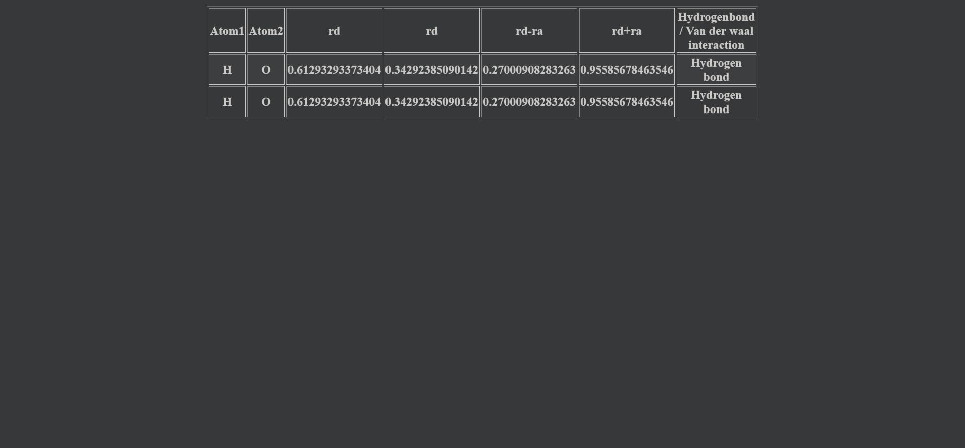

**Result:**

The given task is successfully executed.